Dear Board Members of (location) (Rotary/Lions/CWA/Apex/Soroptimist/Zonta) Club,

I’m (name) and I teach (class) at (school).

My class is keen to support a Rotary project SchoolKits for Congo.

The children have made Tiny Books for Congolese children, who have slates and blackboards but no books at all. They also did a (fundraising activity) to raise some funds towards the project. It raised (sum) and did (list) learning activities to increase their undertanding.

The students forward to the delivery of the books along with a SchoolKit, of a
uniform and bag, sewn by mothers only slightly less struggling to house and educate their
children.

The project achieves sustainable development goals by improving access to education and
training and working with SewAid International to equip self sufficiency through stable employment.

This activity has given the children a more global perspective and some insight into the range of conditions that children experience around the world.

Importantly, it has enabled them to experience being one of the helpers, part of a solution, to be generous and kind, and to make a contribution to a group effort, to tackle an important task.

Please will your club help us to fund this gift? It costs $35 per SchoolKit delivered and we have (number) children in our class.

The recipient children will be photographed with their gifts, both separately for the separate young artists, and all together (with a thank you banner) for your club.

We can invite the local paper to photograph us with our photos, and send them a picture of the club members too, so that our community can enjoy this intergenerational cooperation for good.

Will you help us?

Kind regards,

(Name)

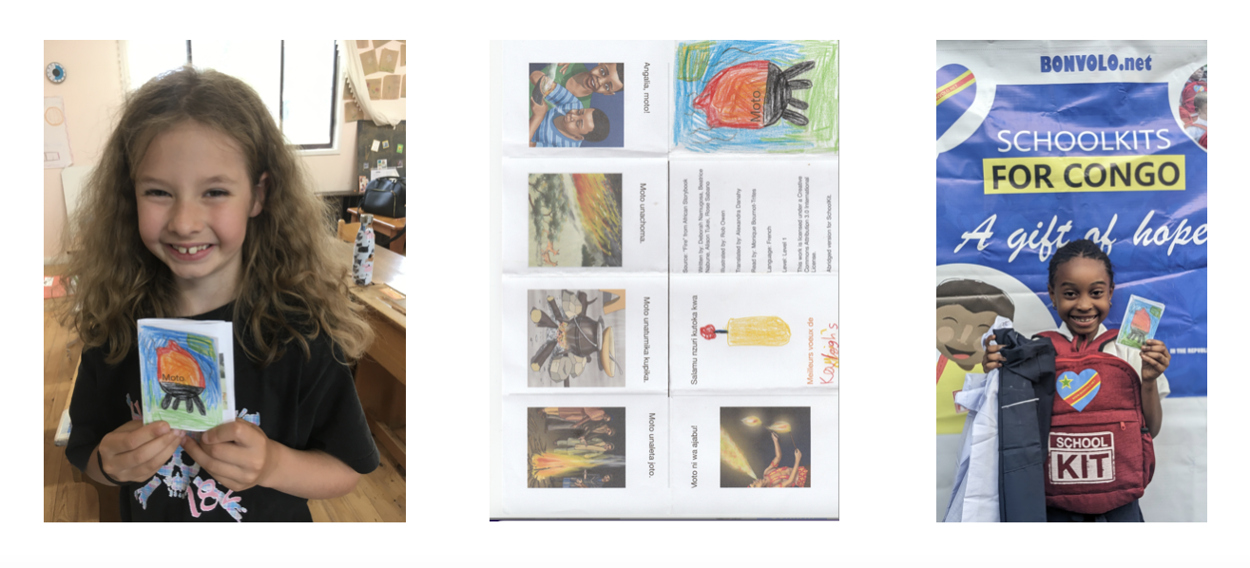
p.s. More information on the SchoolKits program is available at www.bonvolo.net/shoolkit

Good Afternoon,

Next (day), children in (class and school) will be making picture books for children in Congo who have no books at all. They would probably like to show you their art!

About a week later, they will receive individual photos of each of their books in the hands of a happy recipient, and that will be pretty photogenic too 🙂

The activity is organised by SchoolKits for Congo, an initiative of Rotary Australia World Community Service, and this particular distribution of books, school bags and uniforms to the poorest children in Goma, is funded by (name of service club)

The exact time of the activities can be confirmed on the day with (who) on (phone)

More information on the program is available in the links below and I would be happy to answer any other questions you might have. Would this make a good story for (name of paper)?

Kind regards,
(Name)
(Phone)

Links to SchoolKits for Congo info

https://www.bonvolo.net/schoolkit
https://www.facebook.com/profile.php?id=61554120833036

